# Wikimedia

## Definition

**# Source**: **Windows ScreenShots (using Lightshot Program)** **From Site -> https://www.wikimedia.org/ at [10/27/2025]**

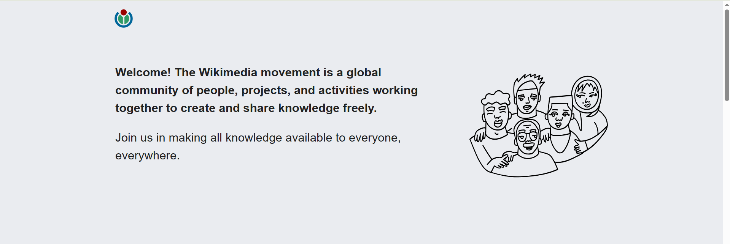

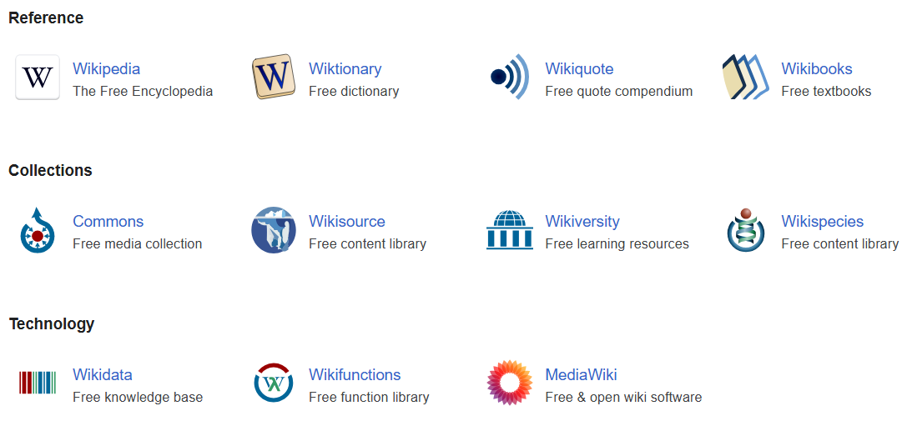



**# Source**: **Chatgpt (GPT-5-Standard) at [10/27/2025]**

**Wikimedia** is the name of the **organization and movement** behind **Wikipedia** and several other free knowledge projects.

Here’s a clear breakdown:

## 🏛️ Wikimedia Foundation

**# Source**: **Chatgpt (GPT-5-Standard) at [10/27/2025]**

* It’s a **nonprofit organization** based in the United States.
* It **owns and operates** Wikipedia and other related sites.
* Its mission is to **empower and engage people around the world to collect and develop educational content** under a free license.

**🌐 Wikimedia Projects**

**# Source**: **Chatgpt (GPT-5-Standard) at [10/27/2025]**

The Foundation runs a family of **free and open knowledge websites**, including:

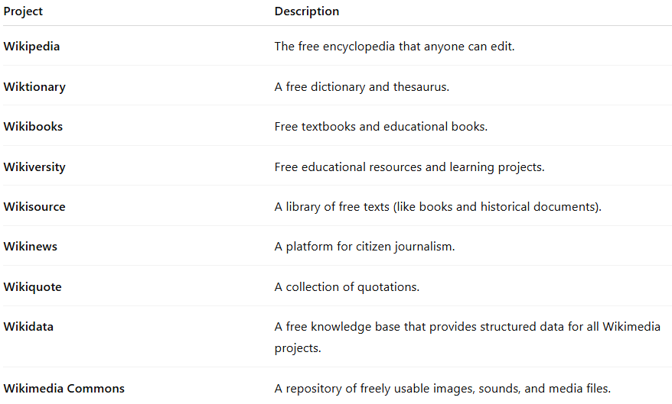

| **Project** | **Description** |
| --- | --- |
| **Wikipedia** | The free encyclopedia that anyone can edit. |
| **Wiktionary** | A free dictionary and thesaurus. |
| **Wikibooks** | Free textbooks and educational books. |
| **Wikiversity** | Free educational resources and learning projects. |
| **Wikisource** | A library of free texts (like books and historical documents). |
| **Wikinews** | A platform for citizen journalism. |
| **Wikiquote** | A collection of quotations. |
| **Wikidata** | A free knowledge base that provides structured data for all Wikimedia projects. |
| **Wikimedia Commons** | A repository of freely usable images, sounds, and media files. |

## 🌍 The Wikimedia Movement

**# Source**: **Chatgpt (GPT-5-Standard) at [10/27/2025]**

* Includes **volunteers**, **editors**, **developers**, and **affiliates** (like local Wikimedia chapters in different countries).
* Works toward **free access to knowledge for everyone**.

## ✅ In short:

**# Source**: **Chatgpt (GPT-5-Standard) at [10/27/2025]**  
**Wikimedia** = The **organization + community + projects** that make Wikipedia and other free knowledge websites possible.